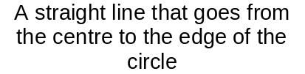
Arc
Sector
Straight line from one point on the circumference to another which does not pass through the centre
Radius
Circumference
Straight line going from all the way across the circle through the centre
Diameter
Tangent
Perimeter of the circle
Area between a pair of radii
and an arc
Chord
Segment
3
4
6
2
1
7
5
8
Parts of the Circle
Part of the circumference between 2 points
The area between a chord and an arc

